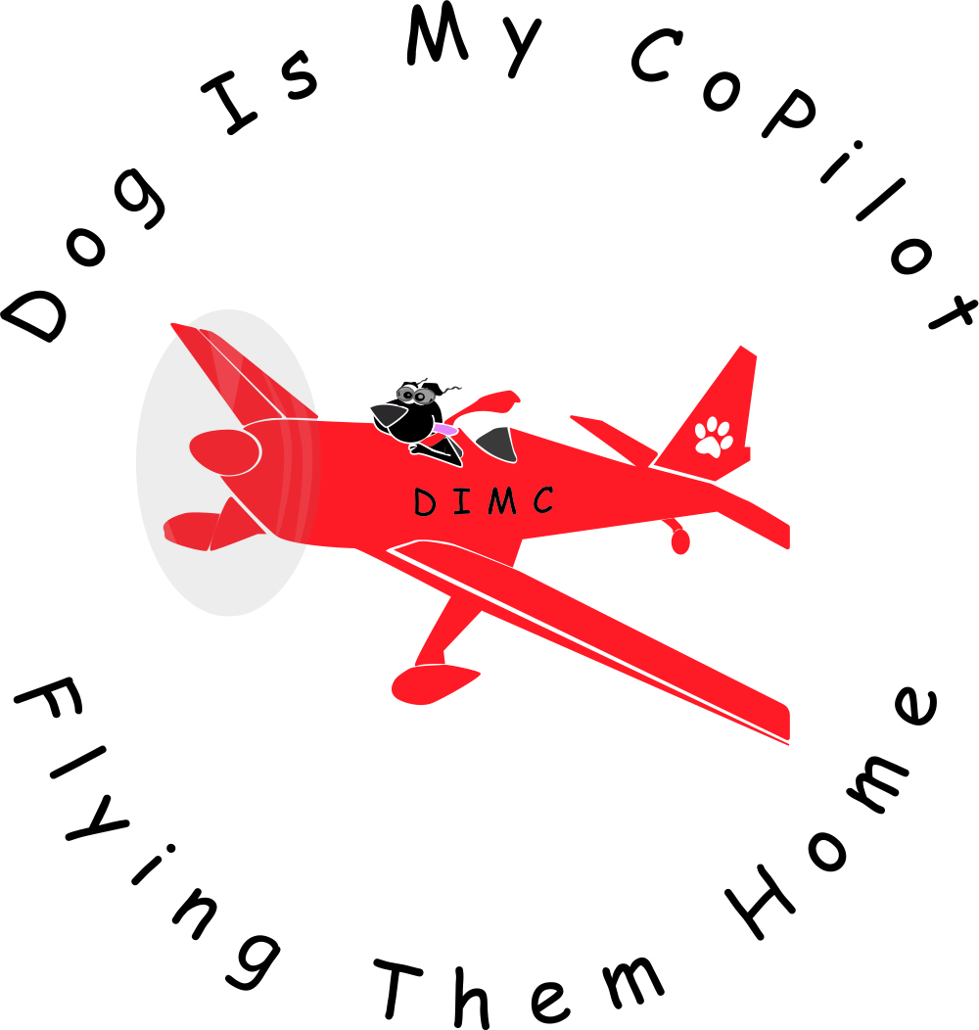
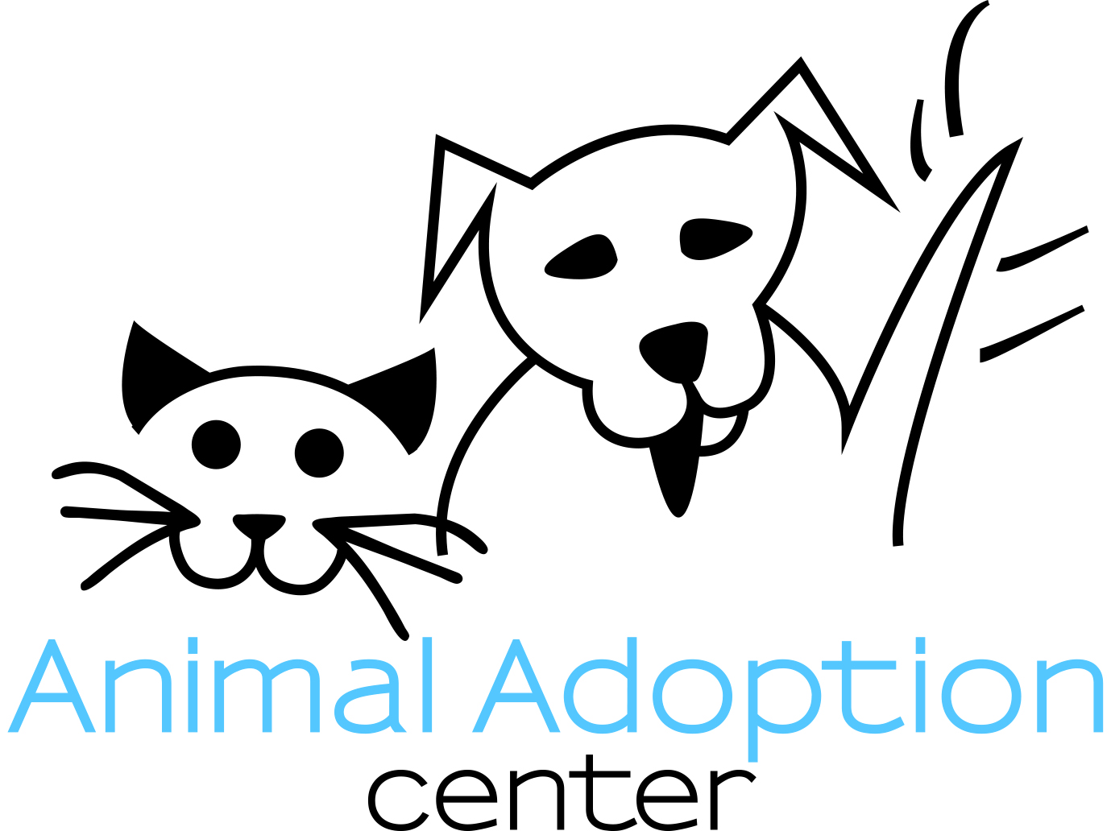

For Immediate Release: September 2, 2020
Contact: Kara Pollard Contact: Carrie Boynton
307-359-5452 307-739-1881
kara@dogcopilot.org carrie@animaladoptioncenter.org
www.dogcopilot.org www.animaladoptioncenter.org

Dog Is My CoPilot’s 16,000th Passenger Lands a Fresh Start
at the Animal Adoption Center

Jackson, WY - On September 3rd, Dog Is My CoPilot (DIMC), a nonprofit air transport organization, will fly 90 dogs and cats from an overcrowded shelter in Laredo, Texas to rescue organizations across the West. The Animal Adoption Center (AAC), one of the 11 receiving partners, will be bringing seven dogs into their rescue program. Six of these dogs are deemed “code red” based on treatable medical conditions that the Laredo Animal Shelter is unable to address due to limited medical funding. While these dogs are deemed unadoptable in Texas, DIMC and the AAC are excited to bring them to Jackson where they can get the care they need before finding loving, forever homes. One of these special dogs, named Patty, marks DIMC’s 16,000th transported animal. Patty is a two year-old Shepard that tested positive for a tick borne illness. Based on these results, Patty and all animals that test positive for this and other illnesses are considered unadoptable at source shelter.

“Our team looks forward to meeting Patty and getting her on the treatment plan recommended by our vet so that she can lead her best life here in the Tetons. It is thanks to the investment of our dedicated donors that we are able to reach not only young, healthy animals, but also help those that are sick, injured, and in need of senior care.” Carrie Boynton, AAC Executive Director.

This flight marks the AAC’s 66th animal transport effort in 2020. In total, the AAC has brought 325 homeless animals from Texas, Utah, Idaho, California, Arizona, and Wyoming into their nonprofit rescue program this year. This has resulted in more than 300 adoptions this year, which is double their average intake and adoption rate.

Since its founding in 2012, DIMC has grown from saving a few hundred lives a year to more than 2,500 annually. DIMC’s success is due to its dedicated team of organizers, supporters, and rescue partners.

"Partnering together with animal organizations like the Animal Adoption Center ensures each animal waiting in an overcrowded shelter has the chance to find a home and we are proud to be working together to save more lives. Every animal we transport saves two; the one that we save and the one that takes its place,” said Dr. Peter Rork, President and Chief Pilot for Dog Is My CoPilot.

ABOUT DOG IS MY COPILOT:
Dog Is My CoPilot is a non-profit organization that transports at risk animals from overcrowded shelters to adoption centers in other geographic regions where loving families are waiting to adopt the animals. We provide our air transportation services at no cost to the shelters and adoption centers. Since our inception in 2012, DIMC has flown over 15,000 animals to safety. To learn more visit: https://dogcopilot.org
About the Animal Adoption Center
Animal Adoption Center (AAC) is dedicated to saving the lives of homeless animals through rescue, adoption, education and spay/neuter. Since inception in 2004, the AAC has rescued and found loving homes for more than 4,000 animals. The AAC also attacks the root of the pet overpopulation problem through its Spay/Neuter Wyoming Program, which has provided free and low-cost spay and neuter services to over 15,000 animals across the state of Wyoming. Learn more at www.animaladoptioncenter.org or call Carrie Boynton at 307-739-1881.

